**MODULE 1**

1. **What is SDLC**

SDLC : software development life cycle

Software development life cycle (SDLC) is a process used by software industry to design, development and test high quality Software.

The development process goes through several stages as developers add new features and fix bugs in the software.

**2.What is agile methodology?**

A Project management approach that prioritize cross-functional collaboration and continuous improvement. It divides projects into smaller phases and guides teams through cycles of planning, execution, and evaluation.

**3. What is software testing?**

Software testing is a method to check whether the actual software product matches expected requirements and to ensure that software product is defect free.

**4. What is SRS**

SRS Stands for “Software Requirement Specification.”

SRS is a document that describes what the software will do and how it will be expected to perform.

**5. What is oops**

As the name suggests, Object –Oriented Programming or OOPS refers to languages that use objects in programming. They use objects as a primary source to implement what is to happen in the code. Objects are seen by the user.the main aim of OOP is to bind together the data and functions that operate on them so that no other part of the code can access this data except that function.

**6. Write Basic Concepts of OOPS**

Basic concepts of object oriented programming are-

1. OBJECTS

2 .CLASS

3. POLYMORPHISM

4. ENCAPSULATION

5. INHERITANCE

6. ABSTRACTION

**7. What is Object**

An Object is a sample of a Class. It is an entity with characteristics and behavior that are used in the object oriented programming. An object is the entity that is created to allocate memory.

**8. What is Class**

The Class is one of the basic concepts of OOPS which is a group of similar entities. It is only a logical component and not the physical entity.

**9. What is encapsulation**It is defined as the wrapping up of data under a single unit. It is the mechanism that binds together the code and the data it manipulates.

**10. What is Inheritance**

A concept that acquires the properties from one class to other classes. I

Inheritance allows programmers to create classes, to specify a new implementation while maintaining the same behaviours, to reuse code and to independently extend original software via public classes and interfaces.

**11. What is Polymorphism**

Polymorphism allows to perform a single action in different ways.

**12. Write SDLC phases with basic introduction**

**OR**

**13.Explain phases of the waterfall model**

**Requirements gathering-** this phase involves gathering information about the software requirements.

**Analysis-**model and specify a solution -“what”

**Design-**includes the overall architecture of the software.

**Implementation-**the design is then implemented in code.

**Testing-**the software is thoroughly tested to ensure that it meets the requirements and works correctly.

**Maintenance-**includes ongoing support, bug, and updatesto the software.

**14. Write Phases of Spiral Model**

**Planning-** it includes estimating the cost, schedule and resources for the iteration. It also involves understanding the system requirements for continuous communication between the system analyst and the customer

**Risk Analysis-** Identification of potential of risk is done while risk mitigation strategy is planned and finalized

**Engineering-** it includes testing, coding and deploying software at the customer site

**Evaluation-** Evaluation of software by the customer. Also, includes identifying and monitoring risk.

**15. Explain Working methodology of agile model and also write pros and cons.**

The agile methodology is a Project management approach that involves breaking the project into phases and emphasizes continuous collaboration and improvement.

Pros :

1. In Agile methodology the delivery of software is unremitting.
2. The Customer are satisfied because after every sprint working feature of the software is delivered to them.
3. In this methodology attention is paid to the good design of the product.
4. Changes in the requirements are accepted even in the later stages of the product.
5. If customer has any changes in the feature then it can be accommodated in the current release of the product.

Cons :

1. In Agile methodology the documentation is less.
2. Sometimes agile methodology is not very clear hence it’s difficult to predict the expected result.
3. In few of the project at the starting of the software development life cycle it’s difficult to estimate the actual effort required.
4. Because of the ever-evolving features, there is always a risk of the ever- lasting project.
5. For complex projects, the resource requirement and effort are difficult to estimate.

**16. Draw usecase on online shopping product using COD**

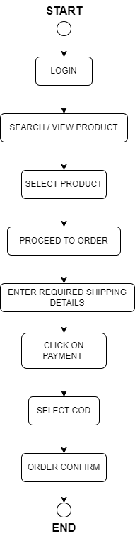

**17. Draw usecase on online shopping product using payment gateway**

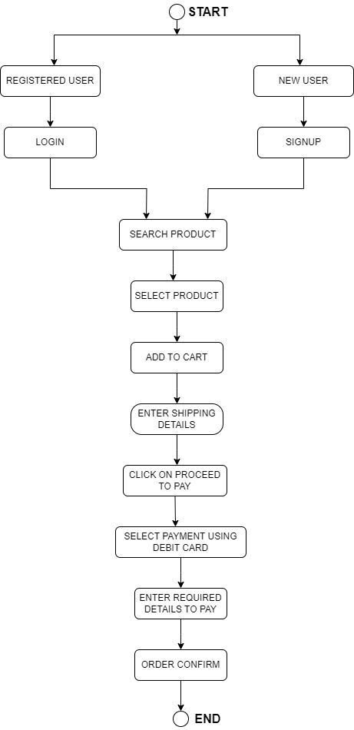

**18. Draw usecase on online book shopping**

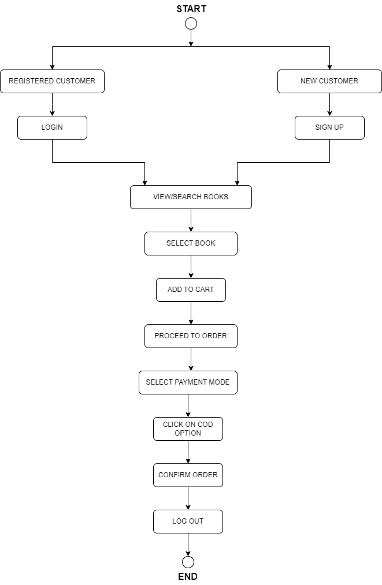

**19. Draw usecase on online bill payment system (paytm)**

